Press invitation - Liège, 5 April 2023

The partners of the EMR H2 Booster project are pleased to invite you to the legendary Spa-Francorchamps circuit on 18 April, from 12:00 onwards! Different cars but also trucks, which is a great premiere in Wallonia, will parade on the legendary Circuit de Spa-Francorchamps.
The pace is accelerating for green hydrogen in Europe and in Wallonia. Indeed, Europe is increasing its ambitions and activities in the field of hydrogen in order to reach its decarbonization objectives and to become independent from fossil fuels. Renewable hydrogen should therefore soon take an important part in the new energy mix.
It is in this dynamic context that the network of green hydrogen actors in Wallonia, in the presence of Minister Henry, Walloon Minister for Climate, Energy, Mobility and Infrastructure, invites the cross-border regions for a day of exchange around an ecosystem dedicated to hydrogen on the scale of the Euregio Meuse-Rhine territory: the Province of Liège (BE), Limburg (BE), Limburg (NL) and Aachen (DE)
Consortium EMR H2 BOOSTER
The Euregio Meuse-Rhine (EMR) H2 Booster is a consortium of nine partners who have joined forces to accelerate the development of clean hydrogen in the Euregio Meuse-Rhine. Its aim? To lay the foundations for a large-scale deployment of a clean hydrogen economy by sharing innovations, demonstrations and knowledge.
The event that the TWEED and SPI are organizing on 18 April aims to bring together companies in the H2 sector that wish to develop cross-border synergies in the form of three sub-ecosystems for EMR:
- EMR H2 road corridor
Development of local hydrogen production, transport and distribution infrastructures, as well as the development of a fleet of heavy vehicles (coaches, trucks and refrigerated trailers) running on hydrogen;
- EMR H2 river corridor
Development of hydrogen production, transport and distribution infrastructures, as well as the development of a fleet of barges running on hydrogen;
- EMR H2 ecosystem including players from the entire hydrogen value chain
Signing of a declaration of common commitments
During this event, to which more than 160 pioneers of the sector have already responded, a declaration of common commitments in favor of the development of the hydrogen sector will be signed by the key players of the four partner regions: the Province of Liège, the Region of Aachen, Flemish Limburg, Dutch Limburg.

Demonstration of hydrogen vehicles on the Circuit
In order to demonstrate the technology of hydrogen vehicles, a parade of different cars and trucks will parade on the Circuit de Spa-Francorchamps from 12.00 onwards. The press is invited to come aboard the fleet and will be able to film the parade as well as interview the many drivers, manufacturers and partners.
Various vehicles have already been announced, including a garbage truck from E Trucks Europe, a dual-fuel H2ice truck from Altrea Haesaerts, a Honda Clarity, a Hyundai Nexo and a Toyota Mirai.
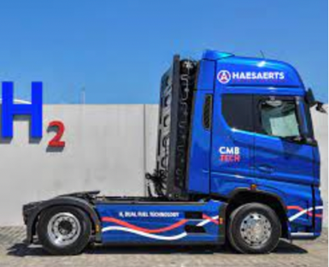
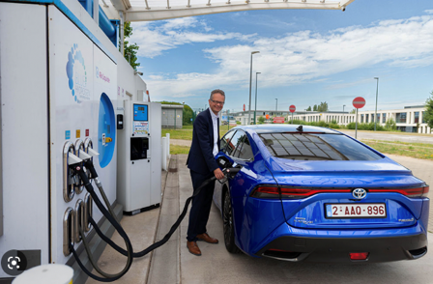
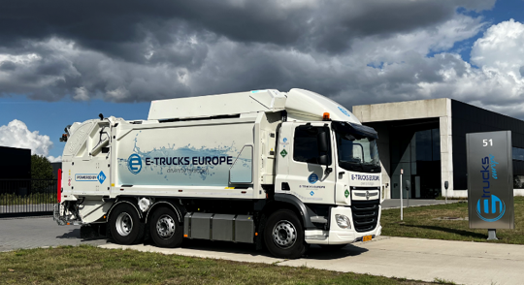

Toyota Mirai
Hydrogen fuel cell car
E Trucks Europe
Hydrogen fuel cell garbage truck
Altrea Haesaerts
H2ice dual fuel truck

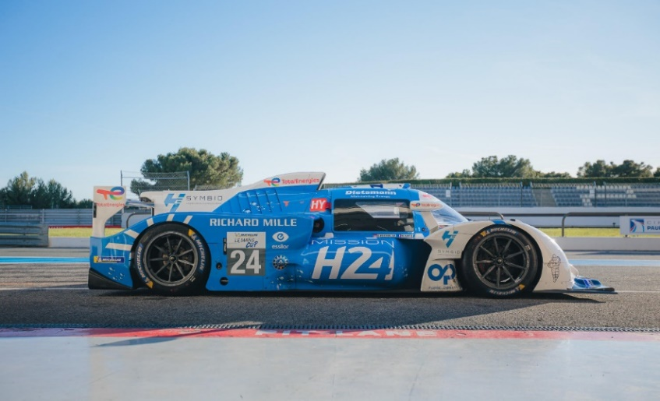

MissionH24, the collaboration between the Automobile Club de l'Ouest and GreenGT which aims to create a category dedicated to hydrogen prototypes at the Le Mans 24 Hours, will also be represented. A hydrogen electric prototype, the LMPH2G, will be on display but for safety reasons will not be part of the parade. As a reminder, the LMPH2G and then the H24 were run at Spa-Francorchamps in the European Le Mans Series, in the Michelin Le Mans Cup. Here is the H24, the latest MissionH24 electric hydrogen prototype.

Inspiring presentations
Many partners and speakers will be present to animate the day, including :
- TOYOTA with Stephan Herbst (Technical Head Powertrain Hydrogen & Fuel Cell Business) for technological innovation;
- HyTrucks with Chris Lefrère (WaterstofNet Project Manager), for a presentation of the HyTrucks Mission with the technological evolution and the differences in subsidies between countries;
- Hy24 with Nicolas Brahy (General Counsel) for the Cost-Effective Support Facility for H2 Mobility Infrastructure. Hy24 is the world's largest fund dedicated to financing infrastructure for the H2 economy +€2bn
- MissionH24, with Bernard Niclot (Head of Hydrogen at ACO and Director of Innovation at MissionH24), for a presentation and feedback on this mission which aims to create a category dedicated to hydrogen prototypes at the 24 Hours of Le Mans.
- Minister Henry, Walloon Minister for Climate, Energy, Mobility and Infrastructure
All these specialists, and many others, will also be available to answer journalists' questions about their programs, commitments and technologies. A press room will be available upon request.
EMRH2 Booster Ecosystem
Finally, the day of 18 April will continue with an International B2B (business to business) session (BE, NL, DE, FR). This session already looks promising thanks to the numerous confirmations of the presence of players representing the entire hydrogen value chain (production, transport, distribution, technology, engineering, integration, applications and end users): Actemium (Vinci), Anglo Belgian Corporation, Airliquide, Air Products, BeBlue-cryotech, Besix Environment, Calysta, CRM group, DATS 24, Engie, Eoly, E-power International, Fluxys, H2 mobility, H24, Hyline (Eiffage), Infra-tech, John Cockerill, Lhyfe, Liqal, PFF-group, H24 Project, Port of Antwerp Bruges, Resa, Shell, Solenco, SGS, Power, Technifutur, Total Energies, Toyota, Tractebel Engie, VH-Technologies, WaterstofNet, Willy Naessens, Ziero, and many others!

More information via Valère COUNET :
+32 (0)478/ 11 69 08 - vcounet@clustertweed.be
and on : https://www.emrh2booster.eu

About EMR H2 BOOSTER :
ABOUT EMR H2 BOOSTER :
EMR H2 Booster is a consortium of nine partners who have joined forces to accelerate the development of clean hydrogen in the Euregio Meuse-Rhine in terms of innovation, demonstration and knowledge sharing. The EMR H2 Booster consortium's action area includes Dutch Limburg, Flemish Limburg, the region of Aachen and the province of Liège.
The 18-month project started on 1 January 2022 and will last until June 2023. The project partners are SPI, Cluster TWEED, Stadt Aachen, LIOF, POM Limburg, IHK Aachen, Universiteit Hasselt, Waterstof Coalitie Limburg and WaterstofNet, the latter having the role of project coordination. Regio Parkstad is an associate partner.
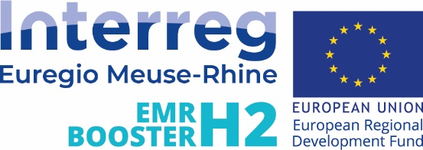
Press contact:
Davine JANSSEN
+32 (0)483/ 70 59 75
davine.janssen@waterstofnet.eu

About Cluster TWEED :
The Cluster TWEED (Technology Wallonia Energy - Environment et Development sustainable) is a Walloon organization bringing together over 200 companies active in the sustainable energy sector. Cluster TWEED aims to play a major role in business in the renewable energy and energy optimization sectors. In addition, TWEED leads an ecosystem dedicated to hydrogen within the Cluster, the H2Hub Wallonia: a network of green hydrogen actors in Wallonia and Brussels.https://clusters.wallonie.be/tweed/fr
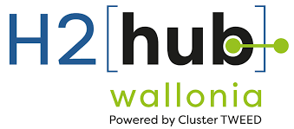
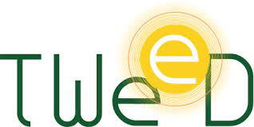
Press contact :
Valère COUNET
+32 (0)478/ 11 69 08
vcounet@clustertweed.be

About SPI :
Spi's role is to accelerate and facilitate the establishment of investors, entrepreneurs and companies in the province of Liege. In addition to welcoming companies, it provides expertise in the areas of territory, data, support and rehabilitation. A wide range of services that responds comprehensively to the needs of companies and public bodies. As an interface between living areas, communities and companies, Spi generates sustainable solutions to the challenges of territorial development.
https://www.spi.be
Press contact:
Pierre CASTELAIN
+32 (0)473/ 50 11 18
Pierre.castelain@spi.be

